Azure App Service - Logic Apps



Vision Scope

Prepared for

Microsoft

2-Feb-16

Version 1.0 Draft

Prepared by

**Ryan Irujo**

Senior Technical Consultant

ryan.irujo@lumagate.com

Contributors

**Add Contributors to Doc Properties**

Table of Contents

1 Before you Begin 3

2 Creating a Logic App using the Azure Portal 4

3 Additional Information 5

1. Before you Begin

The objective of this Guide is to expose the participants to how they can implement Azure Service Apps in their existing Azure Subscription deployment model. At the time of this writing the current requirements to get started are below.

* Admin access to an Azure Subscription (minimum Trial Subscription)
* Visual Studio 2015 Installed (minimum Community Edition)
* Microsoft Azure PowerShell 1.0.1 (November 2015)
* Azure SDK 2.8.1 or higher

Finally, all Scripts, Templates and Applications mentioned within this Guide can be found in Lumagate’s GitHub Repository. If you require access, please contact a member of the Elite Incubation Team at Lumagate.

1. Creating a Logic App using the Azure Portal

In this section, you will be creating a simple Logic App in the Azure Portal that will list out the contents of a particular directory in a Dropbox account; as such, an existing Dropbox account is required to complete this module.

Login to the Azure Portal (<https://portal.azure.com>) and click on **New 🡪 Web + Mobile 🡪 Logic App**.

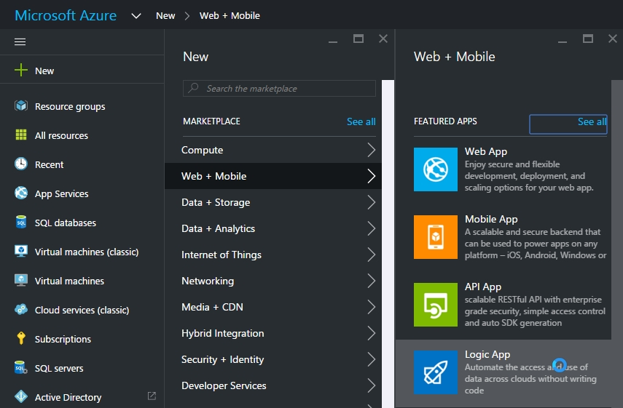

Next, in the **Name** field, type in **mymaildroplogicapp**. Under **App Service Plan**, click on **Or Create New** and type in **mymaildroplogicappplan**. Leave the **Pricing Tier** is set to **Standard**.

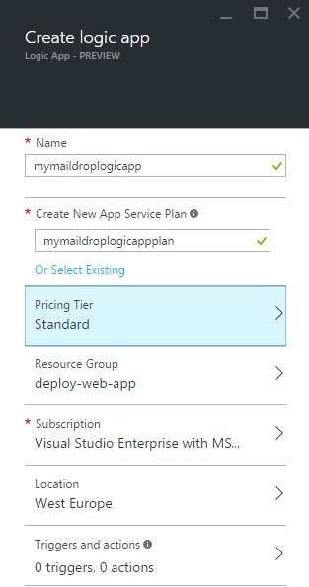

Next, click on **Resource Group** and then click on **Create a new resource group**, name the resource group **mymaildroplogicapp**. Afterwards, click on **OK** and make sure the **Subscription** section is set to the Azure Subscription you wish to deploy to and change the **Location** section to the location you wish to deploy to.

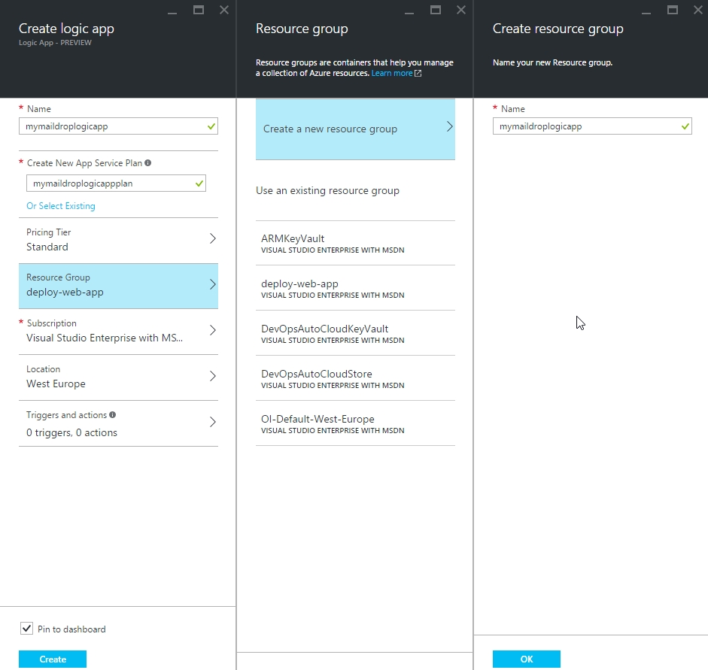

Next, click on **Triggers and actions** and then click on the **Create from scratch** option.

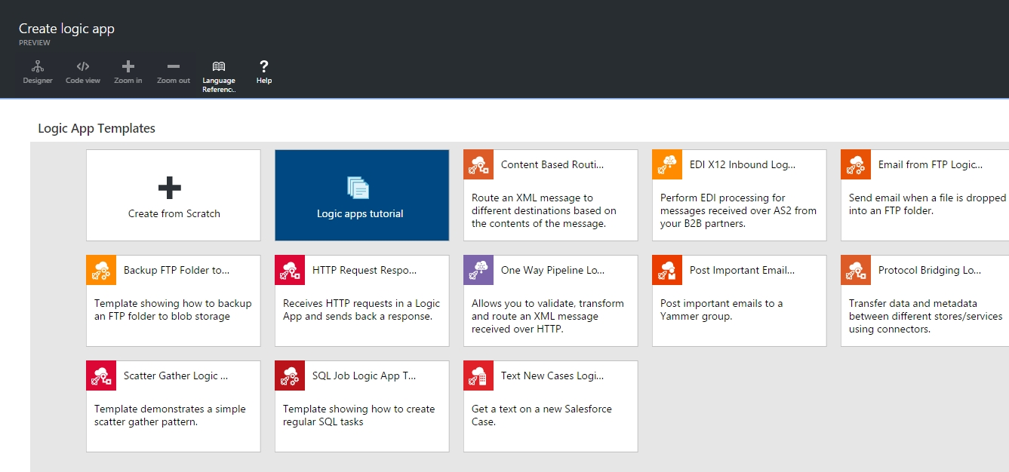

Next, wait for the APIs to load from the right-hand side panel. Once they have loaded, click on the **Office365 Connector**, this will then populate into the main window and state, Connecting to the API… This process could take a few minutes to complete.

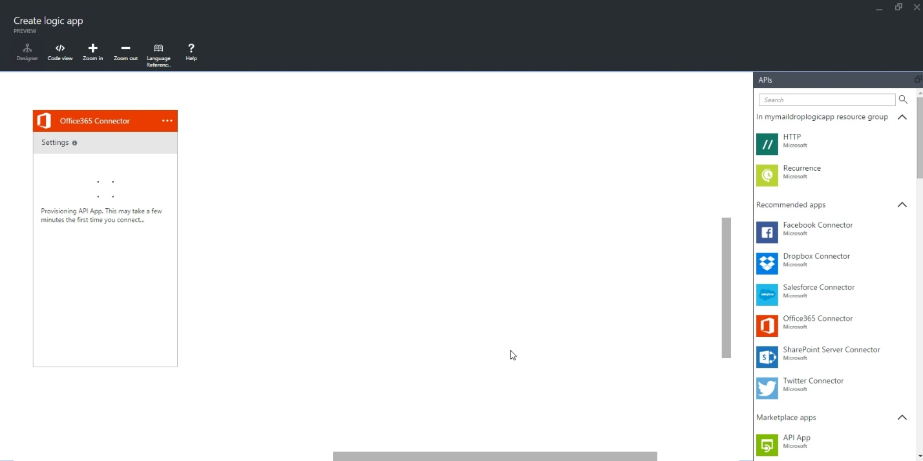

Next, click on **Authorize** and then login to your **Office 365 Account**.

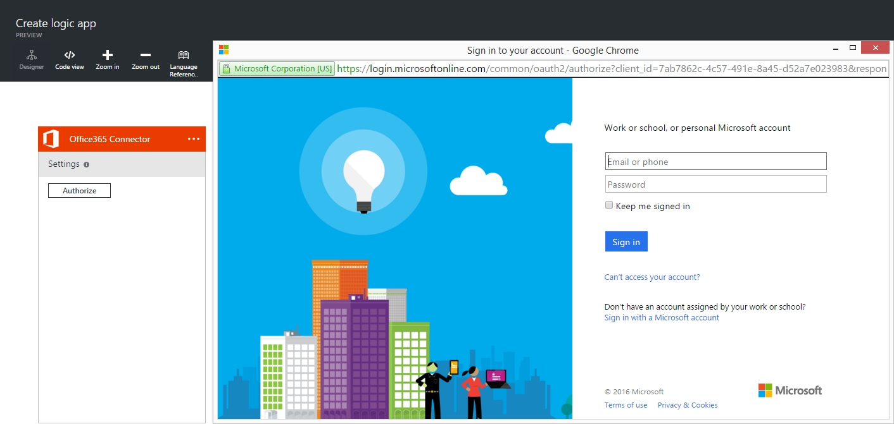

Next, in the Office 365 Connector, click on New Email and then change the Frequency to 1 Minute Intervals and then click on the Green Checkmark button at the bottom.

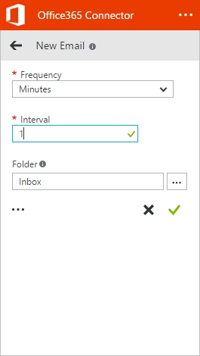

Next, click on the Dropbox Connector from the right-hand side of the APIs Pane and wait for it to finish setting up.

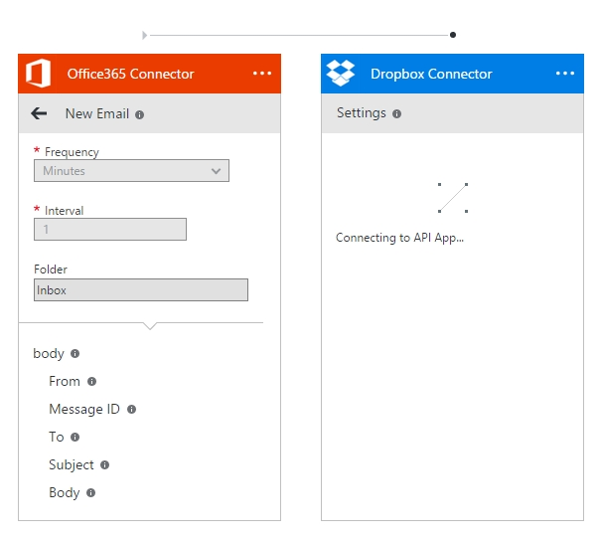

Next,

1. Additional Information

In this section, you will find related information to this Technical Guide that may be of use outside of the presented material.

If the customer does not have a properly configured VPN or Azure Subscription in place, please have them consider the Azure IaaS Foundations IP at http://aka.ms/MCS_EPG_Azure_Iaas-Foundation.

These are just examples; update the requirements adapting to the specific customer situation if necessary. Points to consider might include: tool usage (MAP versus customer provided), server locations, availability of test lab, and so on.